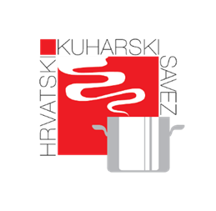
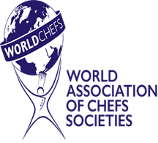

Culinary Seminar Registration Form

Ambienta 2025 - innovations for a sustainable and smart future!

Zagreb, 25th – 28th of September, 2025.
- Pastry Arts Competition Seminar
- Culinary Arts & Hot Kitchen Competition Seminar

Participant Details
Full Name: _________________________________________________________
Contact Number: _________________________ Email: ___________________
Country: _________________________ City: __________________________
Professional Affiliation (Restaurant/Hotel/School): ______________________

Seminar Selection (€200 per seminar)

Both seminars will take place on September the 25th, 2025.
(Please check one or both options)
☐ Pastry Arts Competition Seminar
☐ Culinary Arts & Hot Kitchen Competition Seminar

Payment Details
Total Fee: 200€
Payment Method:
☐ Bank Transfer

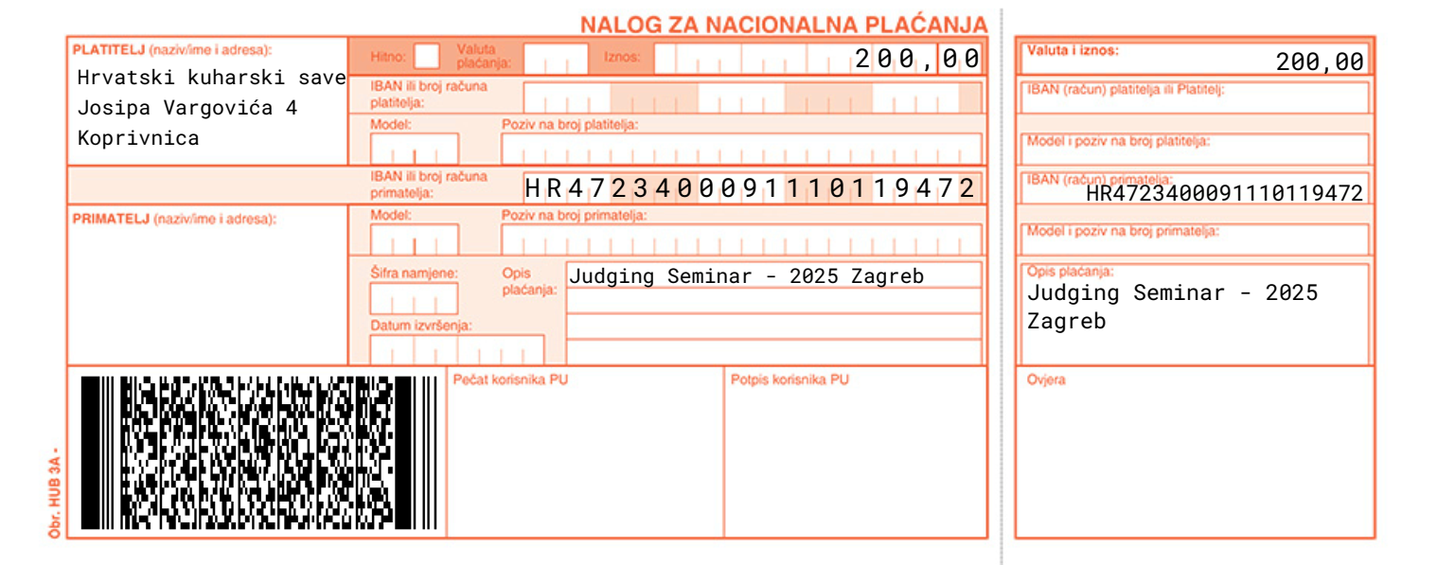

Declaration & Agreement
I, ________________________, confirm my participation in the selected seminar and agree to comply with the event’s rules and regulations. I understand that the participation fee is non-refundable.
Signature: _________________________ Date: _______________

For Official Use Only
Registration Confirmed: ☐ Yes ☐ No
Payment Verified: ☐ Yes ☐ No
Attendee Badge No.: ___________

